# Netflix Project:

Name: Saad Sajjad Roll No: 25SP-033-AI

**NETFLIX CLONE**

A Web Development Project

# Tools Used

In this project, I have used two primary technologies: HTML (Hypertext Markup Language) and CSS (Cascading Style Sheets). These are the building blocks of modern web development.

## HTML

HTML was used to define the structure of the project. It provided the layout for the sign-in page, navigation bar, hero section, FAQs, and footer. With tags such as <div>, <form>, <input>, <button>, and <nav>, I was able to create a clear and organized structure. Forms were implemented for user authentication, and headings/subheadings were added to mimic Netflix’s interface.

## CSS

CSS was responsible for styling the project. It controlled the design aspects such as background colors, fonts, spacing, positioning, and responsiveness. I used Flexbox for alignment, background images for the hero section, and hover effects for buttons and FAQ boxes. Netflix’s trademark red and black theme was replicated to give the project a professional appearance.

## Integration of HTML and CSS

HTML and CSS were linked to work together effectively. The HTML file provided the skeleton, while CSS enhanced the look and feel. For example, the Sign In page structure was coded in HTML, but styling such as button color, input field designs, and hover effects came from CSS. Together, they allowed me to recreate the Netflix UI in a simple but effective way.

## Development Environment

The development was carried out using a simple code editor (such as VS Code). The project files consisted of HTML for structure and CSS for styling, stored in a well-organized folder with separate assets like images. The browser’s developer tools were used for testing and debugging to ensure proper responsiveness and design.

# Project Development

I began the project by setting up the basic HTML structure and linking the CSS stylesheet. My goal was to replicate the Netflix interface using only HTML and CSS. Below are the main steps I followed during development:

## 1. Header and Navigation

I created a navigation bar with the Netflix logo on the left and a Sign In button on the right. Flexbox was applied to align items neatly. The logo was styled using CSS for proper size and positioning.

## 2. Hero Section

The hero section used a background image with a dark overlay to improve readability. I placed headings, subheadings, and a call-to-action input box in the center. CSS Flexbox was used to center the content both vertically and horizontally.

## 3. Sign In Page

A dedicated sign-in page was built with input fields for email and password. The button was styled in Netflix’s red theme with hover effects. The form was centered using Flexbox to provide a user-friendly design.

## 4. Content Sections

Additional sections with headings, promotional content, and styled images were added. Separation bars were included for a neat layout. CSS was used to handle spacing, colors, and typography.

## 5. FAQ Section

A Frequently Asked Questions section was created. Each FAQ box used hover effects for interactivity. This section added realism to the clone and gave it a professional feel.

## 6. Footer

The footer was built using CSS Grid to display links in multiple columns, similar to Netflix. It provided navigation and completed the page design.

# Summary

The Netflix Clone project successfully recreated the core design of Netflix’s website using HTML and CSS. It demonstrated my ability to structure content with HTML and style it with CSS. Key features include a navigation bar, hero section, sign-in form, FAQ section, and footer.

Through this project, I learned how to combine creativity and technical knowledge to design a professional-looking web application. I improved my understanding of positioning elements using Flexbox and Grid, handling background images, and applying hover effects to enhance interactivity.

The use of Netflix’s red and black theme allowed me to focus on color psychology in UI design. The bold red color represents urgency and action, making it perfect for buttons and call-to-action elements, while black provides a cinematic and modern feel to the layout.

Another key takeaway was learning about responsive design principles. Although the project is primarily desktop-focused, the CSS structure prepares it to be further extended into a mobile-friendly design. The separation of HTML and CSS into different files made the project modular and easier to manage.

In conclusion, this Netflix Clone was not only a design exercise but also a valuable learning project in frontend development. It has given me confidence to take on more complex web development projects in the future, incorporating JavaScript, databases, and backend integration to make a fully functional application.

NetFlix Webpage Index.Html File Screenshots:

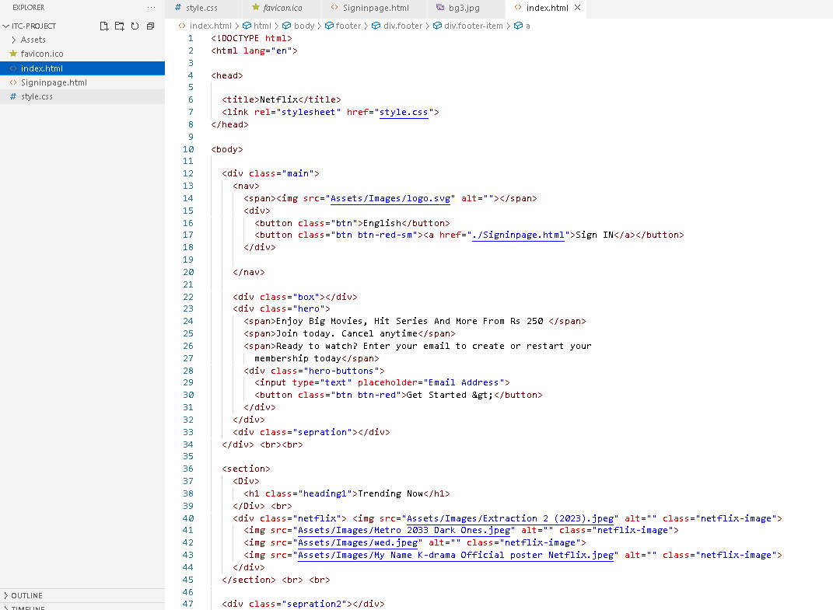

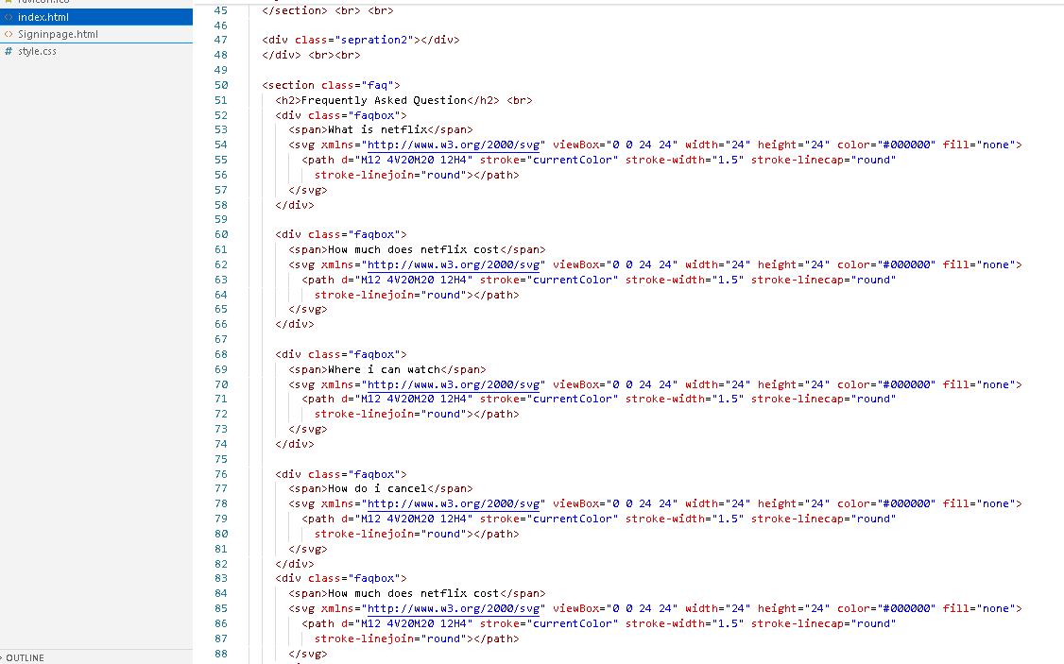

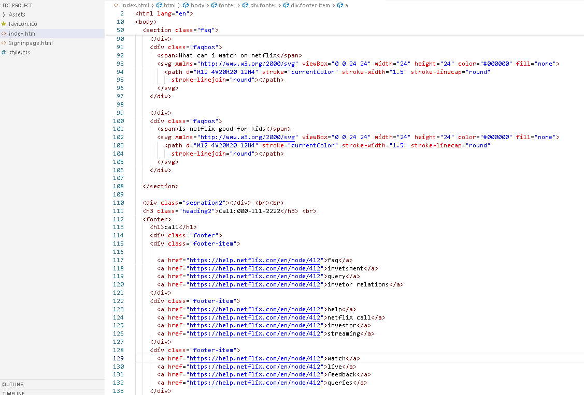

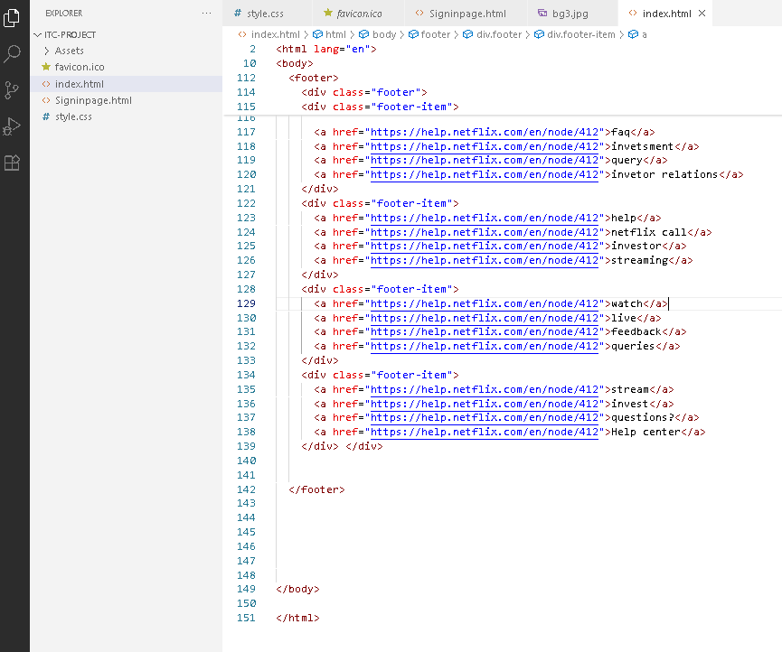

Css Of Webpage:

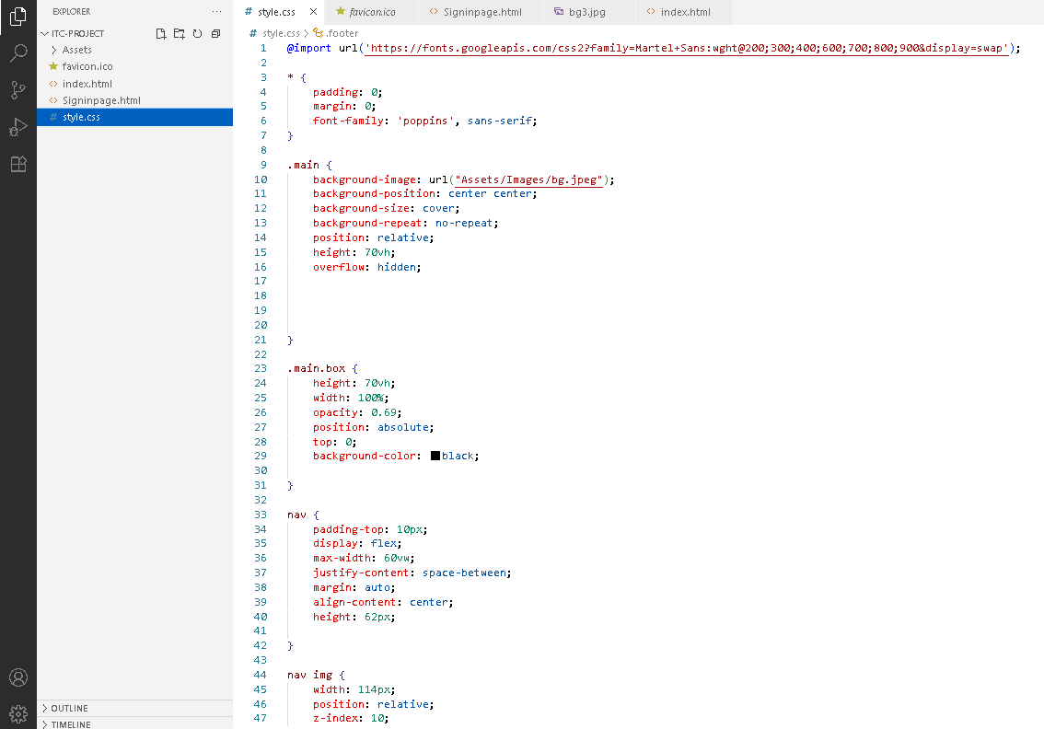

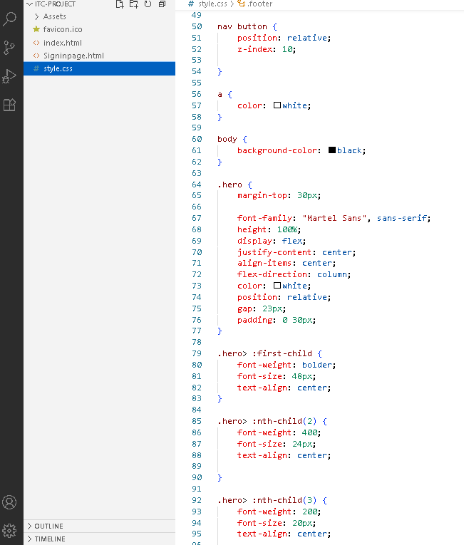

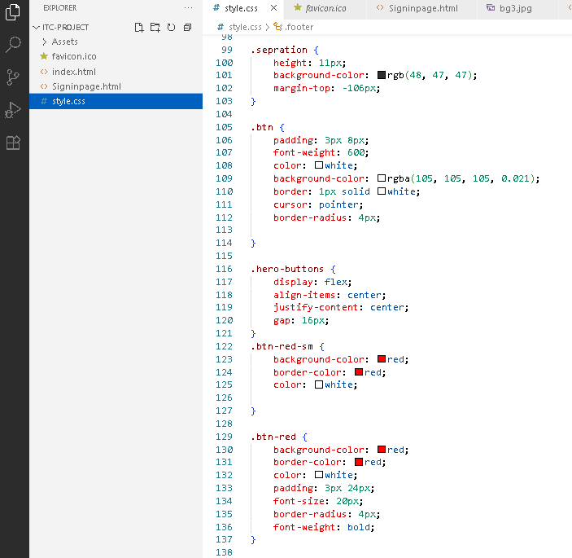

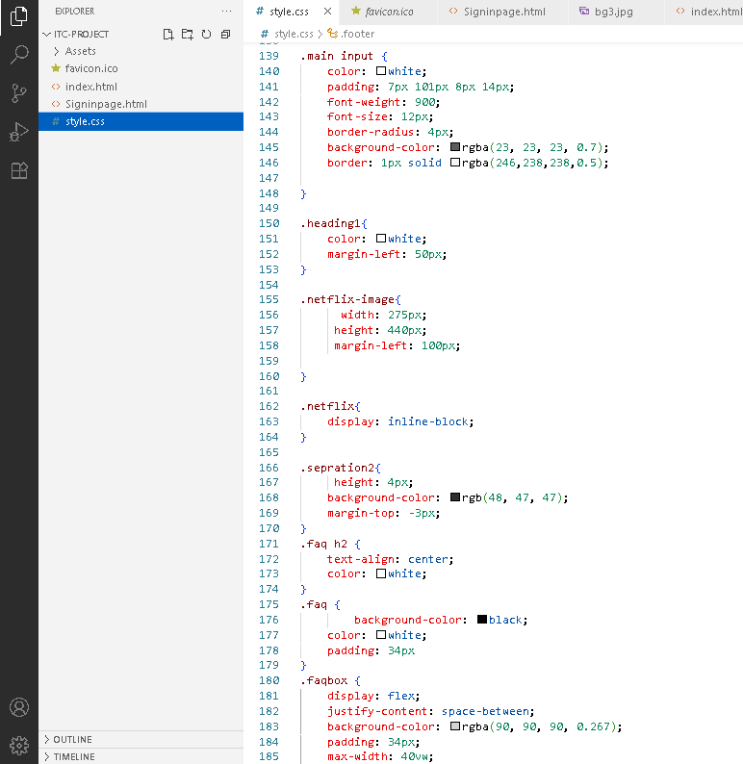

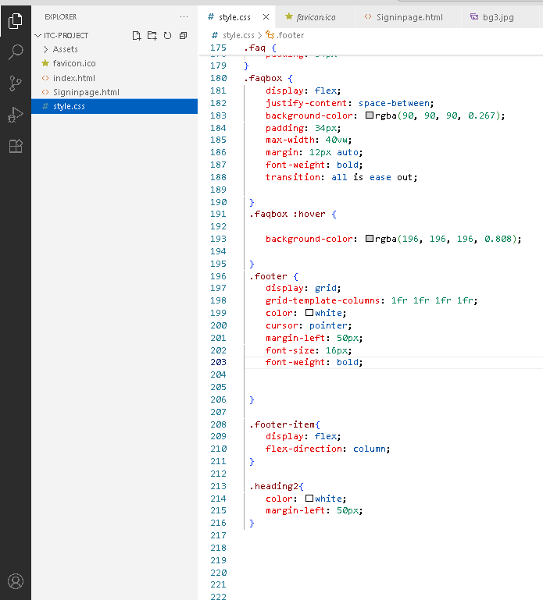

Siginin Page HTML and CSS:

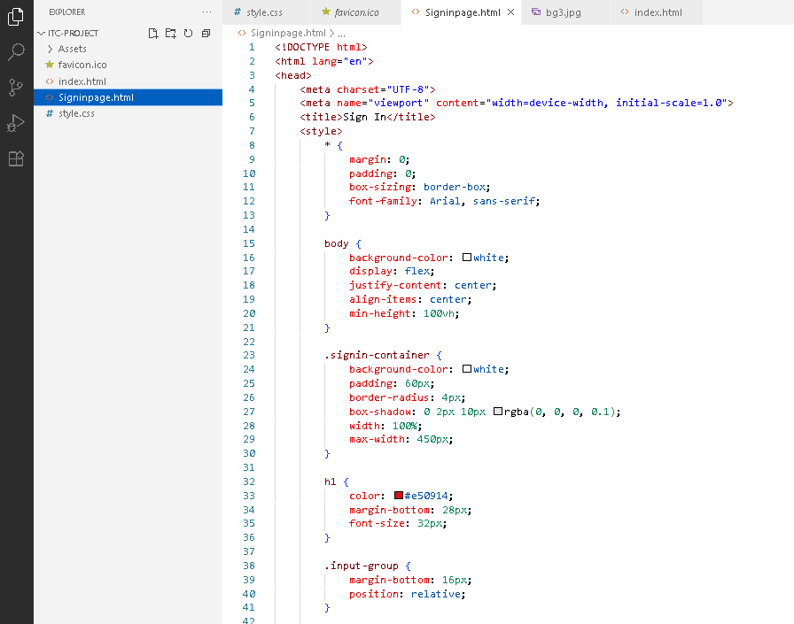

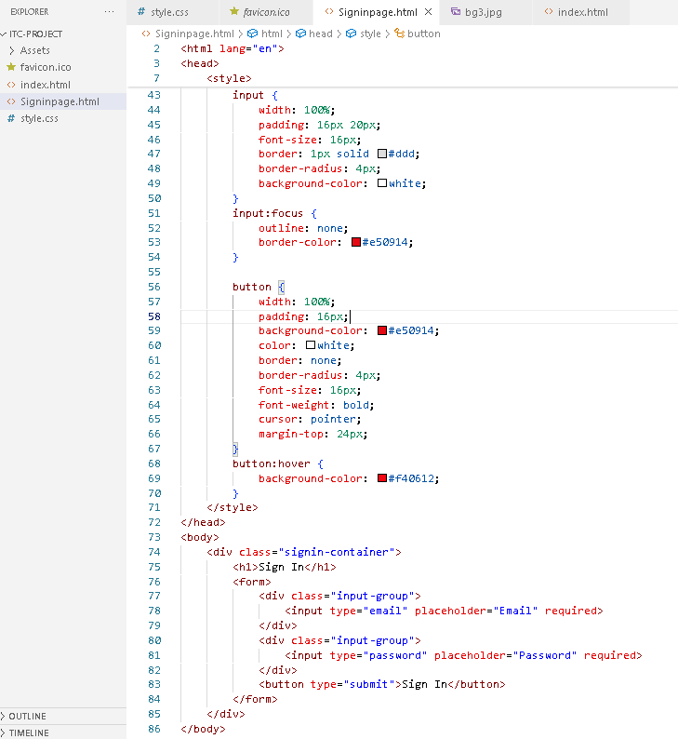

NetFlix Webpage:

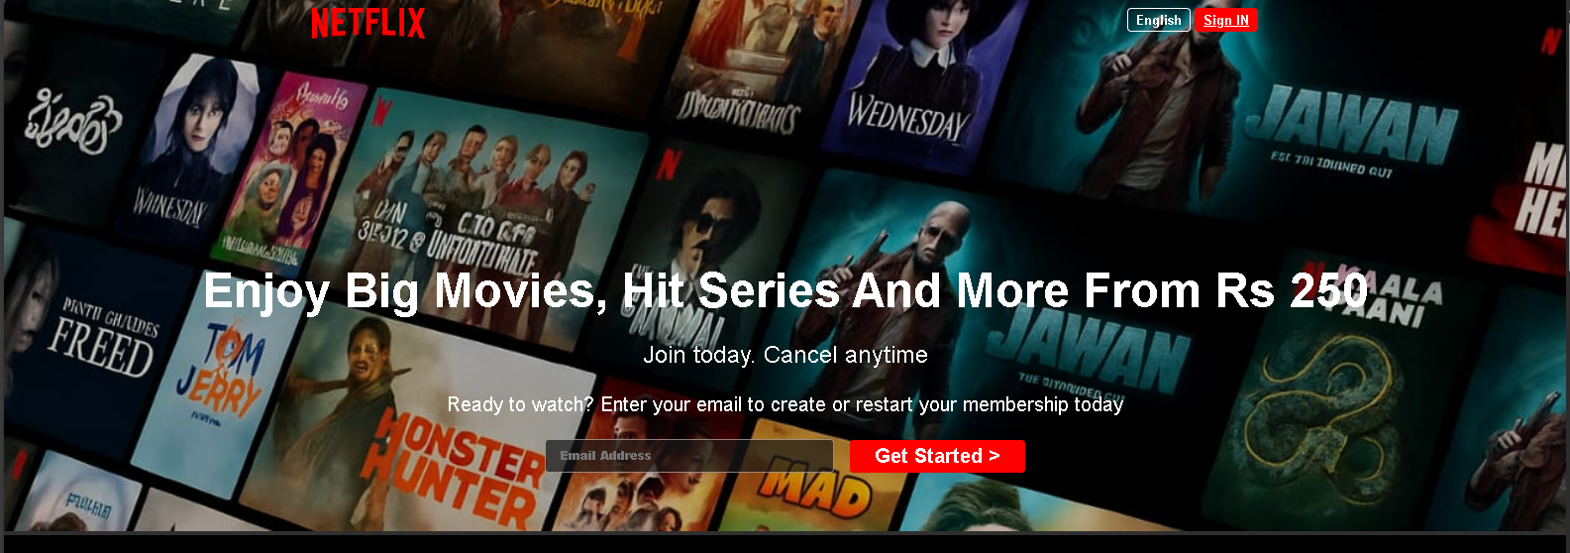

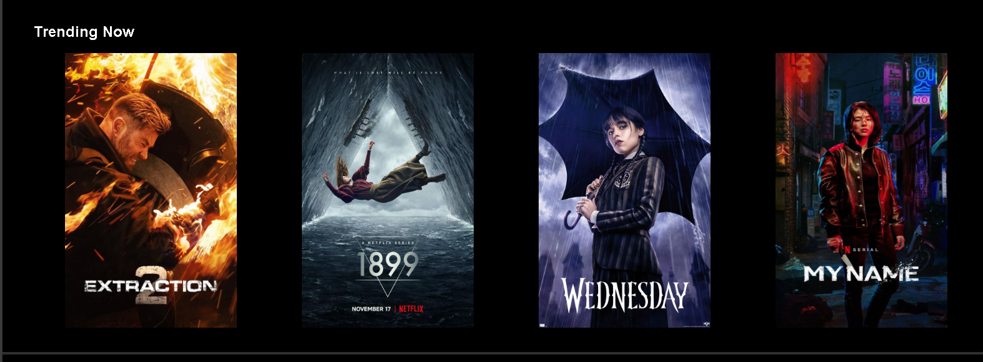

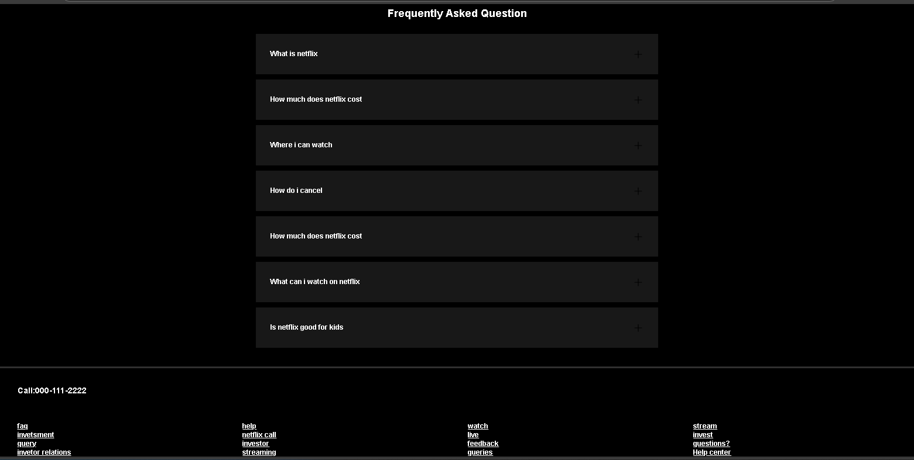

SignIn Page:

